Looking ahead: Key dates for your diary
12-15 May | Y6 SATS Week
26 - 30 May | Half Term (Return Tues 3 June at 8:35am)
Mon 2 June | INSET
Thurs 12 June | Y6 Leavers’ Service – Gloucester Cathedral
Wed 2 July | Sports Day @ Stone CC (time TBC)
Mon 7 - Wed 9 July | Y6 Residential
Fri 18 July | Y6 Leavers’ Service in church (time TBC)
Fri 18 July | Term ends at 2pm - Summer Holidays
Mon 1 & Tue 2 Sept | INSET
Wed 3 September | Term starts at 8:35
Thank you
As we start a new term, I wanted to say a big thank you to all our school community for their support and efforts with our recent Ofsted inspection. To start a term in this way is certainly a bit unusual, but we are proud of the way the children handled it and really appreciate the number of families who responded to the parent voice survey. We should receive the full report by the end of the month and will share with the community once we have it through.
Goodbye and good luck
We are very sad to be announcing that Miss Wright will be leaving us at the end of the current academic year. We are proud of the wonderful teacher she has developed in to and wish her the best of luck for the future, knowing she will be brilliant wherever she goes.
We are currently advertising for a class teacher in Oak class, with interviews taking place before half term and hope to have a new teacher appointed by the end of this term, ready to start in September.
SATS Week May 12th – 15th
Next week is SATs week for our Y6 children, so please do make sure they rest up and ensure they are ready to shine their lights brightly in the mornings by getting a good night’s sleep and having a hearty breakfast. We realise it can feel like a stressful time, so please do look at the link below if anyone is feeling a bit wobbly.
https://www.nhs.uk/mental-health/children-and-young-adults/advice-for-parents/help-your-child-beat-exam-stress/?es_c=C664BD03292C7148C306ABD7B133FA8A&es_cl=AD5F77CCBE24157EEC179C6B8F9B7D2C&es_id=ph7%c2%a3o1


Stone’s Sporting Heartbeat
It has been lovely to hear from families telling us about what children have been getting up to outside of school. Ava (Beech) has earnt her 5m swimming badge, Jack (Willow) took part in a football competition with his local team and were runners up, earning silver medals, and we are also very proud of Josh and Olivia (both Willow) for their musical accomplishments, earning distinctions in their recent piano and violin grade exams.
If you would like to share your child’s sporting exploits with us from outside school, then please send details and images to us and we can celebrate and share in the newsletter.

FOSS
Our wonderful Friends of Stone School are continuing their fundraising for the remainder of the school year. As a community, we are all members of FOSS and I am very grateful to everyone who gives up their time to support the school with their fundraising efforts. We are always on the lookout for people to support and help
The school disco was a huge success, with lots of dancing, some singing and a lot of balloon popping! The children had a great time and did a fantastic job of dancing the night away. It was a lovely way to draw the end of term to a close and we are very grateful to the FOSS team for putting on this event.

Please keep an eye out for exciting news of FOSS’s next event to help start the summer in style!

Courageous Advocacy in School
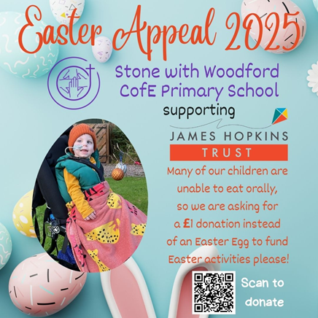
As part of our spiritual exploration of the world, it is important that our children look at where they fit in to the world around them, from family and friends, to the wider world, to the great beyond. Thinking about others is an important part of our personal development, and this is where courageous advocacy comes in. Courageous advocacy is the act of speaking out against an issue of injustice, often on behalf of those whose voice is not heard.
The James Hopkins Trust, based in Gloucester, had their big Easter Appeal before the Easter holidays, and I am very proud to say we raised over £90 for this amazing cause. We would like to say a big thank you to our school council who helped organise the cake sale and express pour gratitude to families who came along and bought the yummy treats.

Safeguarding Update

The latest Gloucestershire Safeguarding Adults Board (GSAB) newsletter highlights key safeguarding topics, including self-neglect, county lines, and forced marriage. It reminds us to stay vigilant and act promptly if we notice signs of vulnerability or exploitation in our community.
For more information or to report a concern, visit www.gloucestershire.gov.uk/gsab. Safeguarding is everyone’s responsibility.

