Looking ahead: Key dates for your diary
Mon 1 & Tue 2 Sept | INSET
Wed 3 September | Term starts at 8:35
End of Term and the Year
As we reach the end of another school year, it’s a good time to pause and reflect on all that we’ve achieved together as a school community.
This year has been full of energy, laughter and learning – and these last few weeks have certainly felt very full. Whilst I may have only been a member of the Stone family since January, I feel very proud to be able to lead such a wonderful school that is filled with such fantastic pupils, families and staff. The children continue to impress us with their curiosity, kindness, resilience and respect. Whether through creative work in class, success on the sports field, thoughtful contributions in collective worship or simply they way they support each other throughout the school day, we see them shine brightly so much. These acts help show what makes Stone with Woodford such a special place.
As always, the end of term is a bittersweet time. We say farewell to our beloved Year 6 children as they move on to secondary school with our very best wishes and enormous pride in all they have accomplished. We also say a fond farewell to staff who are moving on as we say goodbye to Miss Wright after several years in Oak class.
We now look forward to a well-deserved restful summer before beginning again in September – refreshed, recharged and ready for all the opportunities a new year brings.
Y6 SATS Results
Whilst we are saying goodbye to our Y6 pupils, we can truly say they have left in style, delivering some amazing SATS results and leaving with their heads held high! The results below show how our data is well above the national average and is testament to the hard work, determination and skill of all the staff who have worked with the children in KS2, but particularly to Ms Murrin and Jackie in Willow.
Subject | SWW Result @ EXS/GDS | National Ave EXS | SWW Result @ GDS
Reading | 92% | 75% | 58%
Writing | 92% | 72% | 42%
Maths | 92% | 74% | 67%
GPS | 83% | 73% | 50%
RWM comb. | 92% | 62% | 42%
Willow Class Trip to Nature in Art
Willow recently had a fun day out at Nature in Art, where they were able to explore the grounds of the house and see how nature has inspired various artists and sculptors over the years. They then took this inspiration to create some glorious pieces of art themselves using wax and dye on cloth and then creating butterflies from wire and resin. Their finished products were amazing.
FOSS
Firstly a huge thank you to all the volunteers that have helped FOSS by either helping to run the events or donating to them – it’s always welcomed and very appreciated!
FOSS SUMMER FAIR
A huge and heartfelt thank you to everyone that supported us yesterday , no small task given the weather!
We couldn’t have done it without all your donations too, a big thanks for all those books and teddies too.
The kids seemed to enjoy it and we took over £500 in sales 🙌🏼

These events aren’t easy to organise and run, but when everyone pulls together to get it done, it’s building that feeling of community we need at SWW!🌟
A special mention to all the volunteers that have helped us this year, from ice creams and cake sales to donations and discos!
Thanks to:
Rachael and Scott Kuczaj
Katie and Ben Hearn
Sam and Ali Barnard
Kat Ball
Ash wheeler
Liv hand
Katy Cullimore
Finella Elliot
Narcisa Corodan
Lizi Smith
Michala Hussain
Kerrie
Please follow FOSS on Facebook for updates on events and fundraising
https://www.facebook.com/share/g/1M3nnos9U3/?mibextid=wwXIfr

We are currently focusing on raising money for a new secure fence round the paddock so it can be used more regularly by all the pupils, it’s a great space that is not able to be used at the moment and we know the children will really enjoy it!
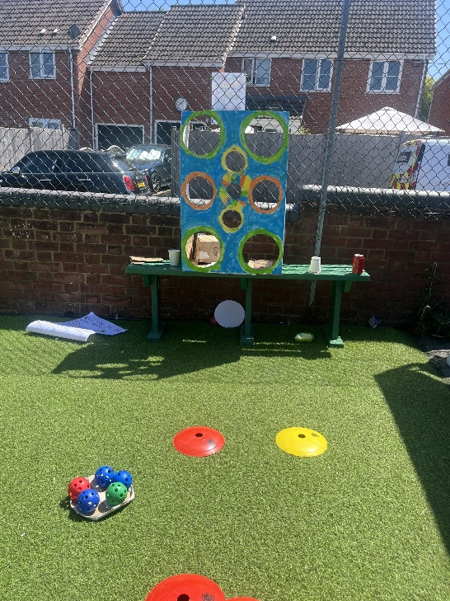
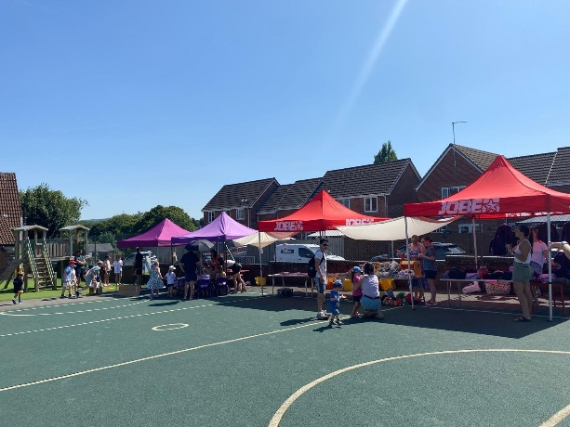
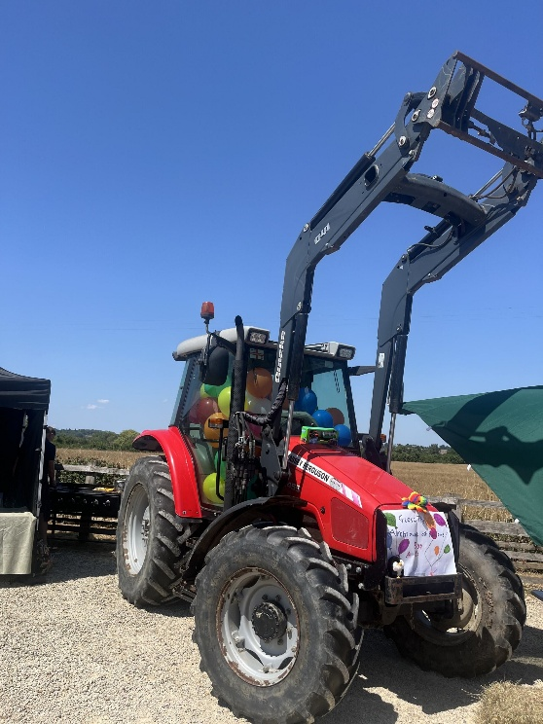
From the FOSS Committee

Safeguarding Update

The latest Gloucestershire Safeguarding Adults Board (GSAB) newsletter highlights key safeguarding topics, including self-neglect, county lines, and forced marriage. It reminds us to stay vigilant and act promptly if we notice signs of vulnerability or exploitation in our community.
For more information or to report a concern, visit www.gloucestershire.gov.uk/gsab. Safeguarding is everyone’s responsibility.

Summer Support
Both GCC and South Glos offer support during the holidays for families entitled to free school meals. Please use the links below if you are interested in these offers.
https://life.southglos.gov.uk/kb5/southglos/directory/advice.page?id=Y50nS-iIHMk

https://www.glosfamiliesdirectory.org.uk/kb5/gloucs/glosfamilies/service.page?id=pFTA2aN5c74
Also, don’t forget the following options for eating out:
