RSE & PSHE (Relationships and Sex Education & Personal, Social, Health Education) Policy
Stone with Woodford CoE Primary School


Approved by: | Governing Board | Date: May 2025
Last reviewed on: | May 2025
Next review due by: | May 2026

Introduction
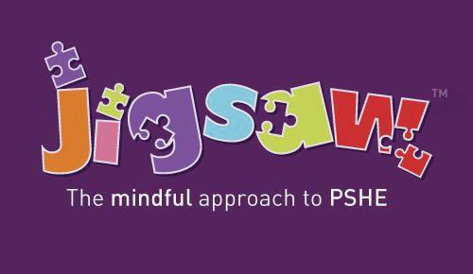
All schools must provide a curriculum that is broadly based, balanced and meets the needs of all
pupils. Under section 78 of the Education Act 2002 and the Academies Act 2010, a PSHE curriculum:
• Promotes the spiritual, moral, cultural, mental and physical development of pupils at the school and of society, and
• Prepares pupils at the school for the opportunities, responsibilities and experiences of later life.

At Stone with Woodford, our Sex, Relationship Education & Personal, Social, Health Education (SRE & PSHE) Policy is deeply rooted in the Christian value of Matthew 5:16, "Let your light shine." This foundational scripture guides us in nurturing our pupils to develop holistically, understanding their own worth and the value of others in the context of respectful, healthy relationships.

Our commitment through this policy is to provide a balanced and age-appropriate curriculum that encompasses all aspects of personal growth, social development, and health education. We believe that by offering a comprehensive understanding of these vital areas, we empower our pupils to make positive, informed choices about their physical, emotional, and social well-being.

The SRE & PSHE curriculum is designed not only to educate but to inspire our pupils to respect themselves and others, cultivating a sense of responsibility and empathy. It aligns with our school’s ethos of kindness, respect, and resilience, preparing pupils to engage constructively with the diverse world around them.

Through this policy, we aim to create a safe and supportive environment where every child can confidently explore and understand the complexities of personal and social relationships. Our goal is to enable each pupil to shine their light brightly, equipped with the knowledge, skills, and attitudes necessary for their personal development and for the betterment of our community.

The Government’s PSHE education review of PSHE Education (March 2013) stated that the subject would remain non-statutory and that no new programmes of study would be published.

However, the Right Honourable Justine Greening, Secretary of State for Education, announced, on March 1st 2017, that it was her intention to make Relationships Education statutory in Primary schools from September 2020 and that content guidance will be published prior to that.

The Children and Social Work Act 2017 placed a duty on the Secretary of State for Education to make the new subjects of Relationships Education at primary and Relationships and Sex Education (RSE) at secondary compulsory through regulations. The Act also provides a power for the Secretary of State to make Personal, Social, Health and Economic Education (PSHE), or elements of the subject, mandatory in all schools. The department engaged with a wide range of interested organisations and conducted a call for evidence on the content of the subjects, and the status of PSHE.

The findings gathered from the process have informed the drafting of the regulations, statutory guidance and regulatory impact assessment, on which the department is now consulting. This includes the department’s decision to make Health Education compulsory, not all of PSHE͘.

The guidance on Relationships Education, Relationships and Sex Education (RSE) and Health
Education for governing bodies, proprietors, head teachers, principals, senior leadership teams,
teachers can be seen here.

We are confident that the Jigsaw Programme covers all aspects of Relationships and Sex Education and Health Education in an age-appropriate way; if there are any gaps, Jigsaw will provide its schools with materials to ensure all statutory duties are fulfilled.

This policy will be updated in line with government guidance when published.

The DfE specified as part of its National Curriculum guidance that ‘ ll schools should make provision for personal, social, health and economic education (PSHE), drawing on good practice’͘ The review also detailed:

“PSHE remains an important and necessary part of all pupils’ education͘ We believe that all schools should teach PSHE, drawing on good practice, and have outlined this expectation in the introduction to the new National Curriculum” (Written Ministerial Statement: Review of Personal, Social, Health and Economic education, March 2013).

This Jigsaw PSHE policy is informed by existing DfE guidance on Sex and Relationships Education
(Sex and Relationship Education Guidance, July 2000), preventing and tackling bullying (Preventing and tackling bullying: Advice for head teachers, staff and governing bodies, July 2013, updated 2017), Drug and Alcohol Education (DfE and ACPO drug advice for schools: Advice for local authorities, headteachers, school staff and governing bodies, September 2012), safeguarding (Working Together to Safeguard Children: A guide to inter-agency working to safeguard and promote the welfare of children, March 2013 and Keeping Children Safe in Education, 2018) and equality (Equality Act 2010: Advice for school leaders, school staff, governing bodies and local authorities, revised June 2014).

The Jigsaw Programme meets all the outcomes in the PSHE Association Programmes of Study, 2017.

Aim of the Jigsaw PSHE policy
To provide pupils with the knowledge, understanding, attitudes, values and skills they need in order to reach their potential as individuals and within the community.
Pupils are encouraged to take part in a wide range of activities and experiences across and beyond the curriculum, contributing fully to the life of their school and communities. In doing so they learn to recognise their own worth, work well with others and become increasingly responsible for their own learning. They reflect on their experiences and understand how they are developing personally and socially, tackling many of the spiritual, moral, social and cultural issues that are part of growing up.

They learn to understand and respect our common humanity; diversity and differences so that they can go on to form the effective, fulfilling relationships that are an essential part of life and learning.
In our school we choose to deliver Personal, Social, Health Education using Jigsaw, the mindful approach to PSHE.

Objectives/Pupil learning intentions:
Jigsaw PSHE will support the development of the skills, attitudes, values and behaviour, which enable pupils to:
• Have a sense of purpose
• Value self and others
• Form relationships
• Make and act on informed decisions
• Communicate effectively
• Work with others
• Respond to challenge
• Be an active partner in their own learning
• Be active citizens within the local community
• Explore issues related to living in a democratic society
• Become healthy and fulfilled individuals

Jigsaw Content
Jigsaw covers all areas of PSHE for the primary phase, as the table below shows:

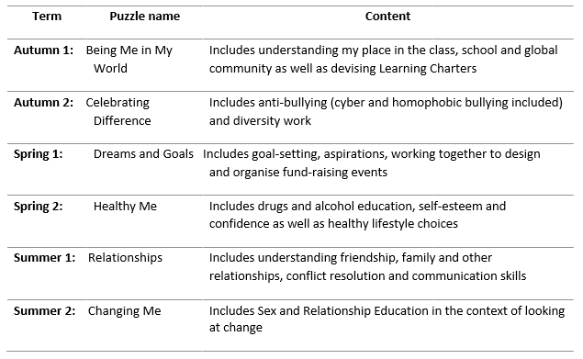

Relationship and Sex Education (RSE)
Definition of Relationship and Sex Education
Since the then Right Honourable Justine Greening, Secretary of State for Education, announced, on March 1st 2017, that it is her intention to make Relationships Education statutory in Primary schools from September 2019, Sex and Relationship Education has now become better known as RSE -
Relationship and Sex Education - to reflect the changes that are to come. However, much of the guidance still refers to it as SRE. Both are used here interchangeably for ease until RSE becomes statutory.
‘Sex and Relationship Education (SRE) is lifelong learning process of acquiring information,
developing skills and forming positive beliefs and attitudes about sex, sexuality, relationships and feelings’ (Sex Education Forum, 1999)͘
Effective RSE can make a significant contribution to the development of the personal skills needed by pupils if they are to establish and maintain relationships. It also enables children and young people to make responsible and informed decisions about their health and well-being.
RSE makes an important contribution to health and well-being by supporting children and young people's ability to learn, achieve and flourish.
"The right to education includes the right to sexual education, which is both a human right in itself and an indispensable means of realising other human rights, such as the right to health, the right to information and sexual and reproductive rights."
Report to the UN General Assembly - July 2010 | Item 69, paragraph 18
Current RSE requirements
Maintained primary and secondary schools are legally obliged to have an up-to-date RSE policy that describes the content and organisation of RSE taught outside science in the National Curriculum.
This includes special schools. In primary schools if the decision is taken not to teach RSE beyond the National Curriculum this should also be documented in the policy. The policy should be made available to parents/carers on request͘ It is the school governors’ responsibility to ensure that the policy is developed and implemented. School governors are in law expected to give ‘due regard’ to the SRE 2000 guidance and to maintain an up to date RSE policy which must be made available to parents/carers. (Learning and Skills Act, 2000).

It is good practice for academies, free schools, colleges and independent schools to have a policy on RSE. All state-funded schools must publish information in relation to each academic year, about the content of the school’s curriculum for each subject, and this includes any teaching in personal,
social, health and economic (PSHE) education and SRE (see 2.5 in the National Curriculum framework (DfE 2013a) and Statutory Instrument 2012 No. 1124).

There is a useful FAQ section from the Sex Education Forum on RSE.

Compulsory aspects of RSE

The sex education contained in National Curriculum science (Key Stages 1-4) is compulsory in maintained schools. In maintained secondary schools it is also compulsory for pupils to have sex education that includes HIV and AIDS and other sexually-transmitted infections. All state-funded schools must have ‘due regard’ to the Secretary of State’s guidance on SRE (DfEE, 2000)͘ This states
that:

• all children, including those who develop earlier than average, need to know about puberty before they experience the onset of physical changes’
• Children should learn ‘how a baby is conceived and born’ before they leave primary school
The Learning and Skills Act (2000) and the model funding agreements for academies and free schools require that state-funded schools ensure that within sex education children ‘learn the nature of marriage and its importance for family life and the bringing up of children’, and ‘are protected from teaching and materials which are inappropriate’͘ The guidance includes some specific information about meeting the needs of young people, whatever their sexuality, including boys and girls and those with special educational needs. It also has advice about addressing specific issues in RSE such as menstruation, contraception, safer sex and abortion.

RSE and statutory duties in school
RSE plays a very important part in fulfilling the statutory duties all schools have to meet. RSE helps children understand the difference between safe and abusive relationships and equips them with the skills to get help if they need it. State-funded schools have responsibilities for safeguarding and a legal duty to promote pupil well-being (Education and Inspections Act 2006 Section 38).

• Sex and Relationships Education (SRE) is an important part of PSHE Education (DfE, 2014).
• When any school provides RSE they must have regard to the Secretary of State’s guidance; this is a statutory duty. Academies do not have to provide RSE but must also have regard to Secretary of State’s guidance when they do (DfE, 2013)͘ Ofsted will evaluate how schools help to ensure a healthy lifestyle for their children (Ofsted, 2013, Subsidiary Guidance Para 64).
• It is compulsory for all maintained schools to teach the parts of sex education that fall under National Curriculum Science which must be taught to all pupils of primary and secondary age e.g. the biological aspects of puberty and reproduction (Education Act 1996, National Curriculum 2014).
Updated government safeguarding guidance is now available (Keeping Children Safe in Education,2018) and includes a section about being alert to signs that young girls may be at risk of female genital mutilation (FGM). School summer holiday especially during the transition from primary to secondary schools is thought to be a key risk time for FGM. See also the government Multi-agency
practice guidelines: Female Genital Mutilation (2016) which includes a section for schools.
RSE has clear links with other school policies aimed at promoting pupils’ spiritual, moral, social and cultural development, including the:
• Anti-Bullying Policy
• Behaviour Policy
• Drug and Alcohol Education Policy
• Equality Policy
• ICT Policy and Safe Internet Use (part of the staff handbook)
• Inclusion Policy
• RE Policy
• Early Help, Safeguarding and Child Protection Policy
• Special Educational Needs Information Report

The role of the headteacher
It is the responsibility of the headteacher to ensure that staff and parents are informed about the RSE policy, and that the policy is implemented effectively͘ It is also the headteacher’s responsibility to ensure that members of staff are given sufficient training, so that they can teach effectively and handle any difficult issues with sensitivity.
The headteacher liaises with external agencies regarding the school RSE programme and ensures that all adults who work with children on these issues are aware of the school policy, and that they work within this framework. The headteacher monitors this policy on a regular basis and reports to governors, when requested, on the effectiveness of the policy.

Monitoring and Review
The Curriculum Committee of the governing body monitors the sex education policy on an annual basis. This committee reports its findings and recommendations to the full governing body, as necessary, if the policy needs modification. The Curriculum Committee gives serious consideration to any comments from parents about the sex education programme, and makes a record of all such comments. Governors require the headteacher to keep a written record, giving details of the content and delivery of the RSE programme that is taught in your school. Governors should scrutinise materials to check they are in accordance with the school’s ethos͘.

Equalities

The Equality Act 2010 covers the way the curriculum is delivered, as schools and other education
providers must ensure that issues are taught in a way that does not subject pupils to discrimination. Schools have a duty under the Equality Act to ensure that teaching is accessible to all children and young people, including those who are lesbian, gay, bisexual and transgender (LGBT). Inclusive RSE will foster good relations between pupils, tackle all types of prejudice - including homophobia - and promote understanding and respect. The Department for Education has produced advice on The Equality Act 2010 and schools (DfE, 2014b).

Schools have a legal duty to promote equality (Equality Act, 2010) and to combat bullying (Education Act, 2006) (which includes homophobic, sexist, sexual and transphobic bullying) and Section 4.2 of the national curriculum (2014) states “Teachers should take account of their duties under equal
opportunities legislation that covers race, disability, sex, religion or belief, sexual orientation,
pregnancy and maternity, and gender reassignment͘

Jigsaw RSE Content
The grid below shows specific RSE learning intentions for each year group in the ‘Changing Me’
Puzzle.

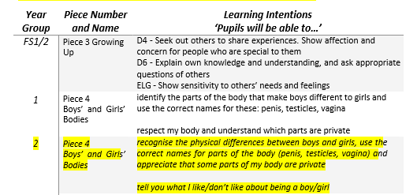
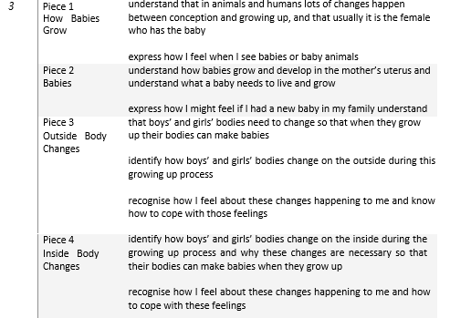
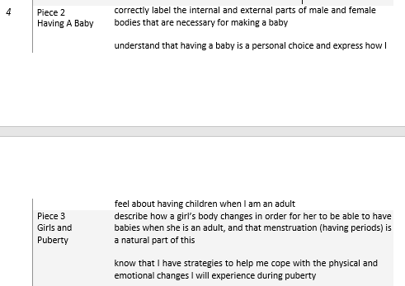
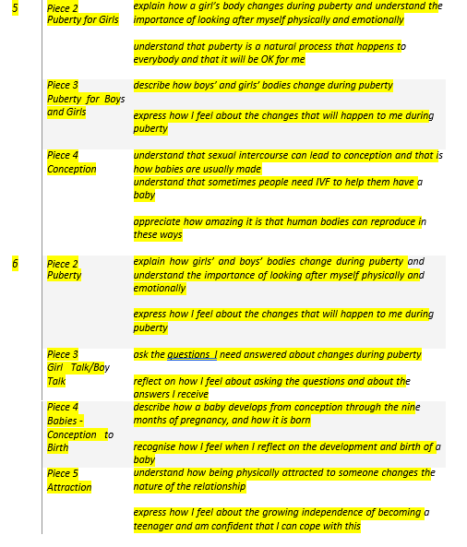

Withdrawal from RSE lessons
Parents/carers have the right to withdraw their children from all or part of the Relationship and Sex Education provided at school except for those parts included in statutory National Curriculum Science. Those parents/carers wishing to exercise this right are invited in to see the head teacher and/or RSE Co-ordinator who will explore any concerns and discuss any impact that withdrawal may have on the child. Once a child has been withdrawn they cannot take part in the RSE programme until the request for withdrawal has been removed. Materials are available to parents/carers who wish to supplement the school RSE programme or who wish to deliver RSE to their children at home.

Working with parents and carers
The government guidance on SRE (DfEE 2000) emphasises the importance of schools working in partnership with parents and carers. Under current legislation schools should enable parents/carers to exercise their right to withdraw their children (until the age of 19) from any school RSE taught outside National Curriculum Science (Education Act 1996). This applies to maintained primary and secondary schools and includes pupils attending a sixth form that is part of a school. It does not apply to sixth form colleges and further education colleges. Parents/carers have a legal right to see the school RSE policy and to be given a copy of it (Education Act 1996). Parents/carers should also be aware that schools are legally required to provide a broad and balanced curriculum. Sex and relationships topics can arise incidentally in other subjects, such as Science, and it is not possible to withdraw pupils from these relatively limited and often unplanned discussions.
How is Jigsaw PSHE organised in school?
Jigsaw brings together PSHE Education, emotional literacy, social skills and spiritual development in a comprehensive scheme of learning. Teaching strategies are varied and are mindful of preferred learning styles and the need for differentiation. Jigsaw is designed as a whole school approach, with
all year groups working on the same theme (Puzzle) at the same time. This enables each Puzzle to start with an introductory assembly, generating a whole school focus for adults and children alike.
There are six Puzzles in Jigsaw that are designed to progress in sequence from September to July. Each Puzzle has six Pieces (lessons) which work towards an ‘end product’, for example, The School Learning Charter or The Garden of Dreams and Goals.
Each Piece has two Learning Intentions: one is based on specific PSHE learning (covering the non-statutory national framework for PSHE Education but enhanced to address children’s needs today); and one is based on emotional literacy and social skills development to enhance children’s emotional and mental health. The enhancements mean that Jigsaw, the mindful approach to PSHE, is relevant to children living in today’s world as it helps them understand and be equipped to cope with issues like body image, cyber and homophobic bullying, and internet safety.
Every Piece (lesson) contributes to at least one of these aspects of children’s development͘ This is mapped on each Piece and balanced across each year group.

Differentiation/SEN
Jigsaw is written as a universal core curriculum provision for all children. Inclusivity is part of its
philosophy. Teachers will need, as always, to tailor each Piece to meet the needs of the children in their classes. To support this differentiation, many Jigsaw Pieces suggest creative learning activities that allow children to choose the media with which they work and give them scope to work to their full potential. To further help teachers differentiate for children in their classes with special
educational needs, each Puzzle includes a P-level grid with suggested activities for children working at each of those levels.
If any changes are implemented nationally as a result of the Rochford Review Jigsaw will make the necessary amendments and offer this free update to all its schools.
Safeguarding
Teachers need to be aware that sometimes disclosures may be made during these sessions; in which case, safeguarding procedures must be followed immediately. Sometimes it is clear that certain
children may need time to talk one-to-one after the circle closes. It is important to allow the time and appropriate staffing for this to happen. If disclosures occur, the school’s Early Help, Safeguarding and Child Protection Policy is followed.

Reporting to Parents/Carers
Each Puzzle’s assessment task and attainment descriptors assist the teacher in reporting meaningful learning progress to parents/carers. The descriptors can be used as a starting point when considering what to write on children’s reports͘.

Monitoring and evaluation
The PSHE co-ordinator (alongside other leaders) will monitor delivery of the programme through
observation and discussion with teaching staff to ensure consistent and coherent curriculum
provision.
Evaluation of the programme’s effectiveness will be conducted on the basis of:
• Pupil and teacher evaluation of the content and learning processes
• Staff meetings to review and share experience

External contributors
External contributors from the community, e.g. health promotion specialists, school nurses, social workers, and community police and fire officers, make a valuable contribution to the Jigsaw PSHE programme. Their input should be carefully planned and monitored so as to fit into and
complement the programme.
Teachers MUST always be present during these sessions and remain responsible for the delivery of the Jigsaw PSHE programme.

The Learning Environment
Establishing a safe, open and positive learning environment based on trusting relationships between all members of the class, adults and children alike, is vital. To enable this, it is important that ‘ground rules’ are agreed and owned at the beginning of the year and are reinforced in every Piece - by using
The Jigsaw Charter. (Ideally, teachers and children will devise their own Jigsaw Charter at the beginning of the year so that they have ownership of it.) It needs to include the aspects below:
The Jigsaw Charter
• We take turns to speak
• We use kind and positive words
• We listen to each other
• We have the right to pass
• We only use names when giving compliments or when being positive
• We respect each other’s privacy (confidentiality)

Teaching Sensitive and Controversial Issues
Sensitive and controversial issues are certain to arise in learning from real-life experience. Teachers will be prepared to handle personal issues arising from the work, to deal sensitively with, and to follow up appropriately, disclosures made in a group or individual setting. Issues that we address that are likely to be sensitive and controversial because they have a political, social or personal impact or deal with values and beliefs include: family lifestyles and values, physical and medical issues, financial issues, bullying and bereavement.
Teachers will take all reasonable, practical steps to ensure that, where political or controversial
issues are brought to pupils’ attention, they are offered a balanced presentation of opposing views. Teachers will adopt strategies that seek to avoid bias on their part and will teach pupils how to recognise bias and evaluate evidence. Teachers will seek to establish a classroom climate in which all pupils are free from any fear of expressing reasonable points of view that contradict those held either by their class teachers or their peers.
Answering Difficult Questions and Sensitive Issues
Staff members are aware that views around RSE- and Drug and Alcohol Education-related issues are varied. However, while personal views are respected, all RSE and Drug and Alcohol Education issues
are taught without bias using Jigsaw. Topics are presented using a variety of views and beliefs so that pupils are able to form their own, informed opinions but also respect that others have the right to a different opinion.
Both formal and informal RSE and Drug and lcohol Education arising from pupils’ questions are
answered according to the age and maturity of the pupil(s) concerned. Questions do not have to be answered directly, and can be addressed individually later. The school believes that individual teachers must use their skill and discretion in this area and refer to the Child Protection Coordinator if they are concerned.
Our school believes that RSE and Drug and Alcohol Education should meet the needs of all pupils, answer appropriate questions and offer support. In Jigsaw Pieces that cover RSE provision, this should be regardless of their developing sexuality and be able to deal honestly and sensitively with sexual orientation, answer appropriate questions and offer support. Homophobic bullying is dealt
with strongly yet sensitively. The school liaises with parents/carers on this issue to reassure them of the content and context.

Involving parents and carers
The school believes that it is important to have the support of parents, carers and the wider
community for the Jigsaw PSHE programme. Parents and carers are/will be given the opportunity to find out about and discuss the Jigsaw PSHE programme through:
* Parent/carer Jigsaw awareness session
* Parents’/carers’ evenings
* Information leaflets/displays/website

Pupil Consultation (via School council)
It is useful for pupils to be consulted on their own personal, social and citizenship development.
We ask pupils either in individual classes or through the school council what sort of person they would like to be by the time they leave this school; what qualities, skills, attitudes, values are important to them as people?

Develop this further by asking pupils how they feel the school could support them with this, what initiatives the school could implement to support this e.g. friendship benches, peer mentoring systems.

Training and support for staff
All staff benefit from Jigsaw PSHE training in order to enhance their PSHE delivery skills.
Opportunities are provided for staff to identify individual training needs on a yearly basis and relevant support is provided.

In addition to this, support for teaching and understanding PSHE issues is incorporated in our staff INSET programme, drawing on staff expertise and/or a range of external agencies.
Dissemination
This policy is available on our school website where it can be accessed by the community. Training is regularly delivered to staff on the policy content. Copies are available from the school office on
request from parents/carers.

Confidentiality and Child Protection/Safeguarding Issues
There is a general rule a child’s confidentiality is maintained by the teacher or member of staff concerned͘. If this person believes that the child is at risk or in danger, she/he talks to the named child protection co-ordinator who takes action as laid down in the Early Help, Safeguarding and Child Protection Policy. All staff members are familiar with the policy and know the identity of the member of staff
with responsibility for Child Protection issues. The child concerned will be informed that confidentiality is being breached and reasons why. The child will be supported throughout the process.

Policy Review
This policy is reviewed annually with the school’s governing board͘.

